**Git Assignment Day-4**

**(tags,log,revert,reset)**

git log –oneline

git tag d503dac

git show d503dac

git push origin d503dac

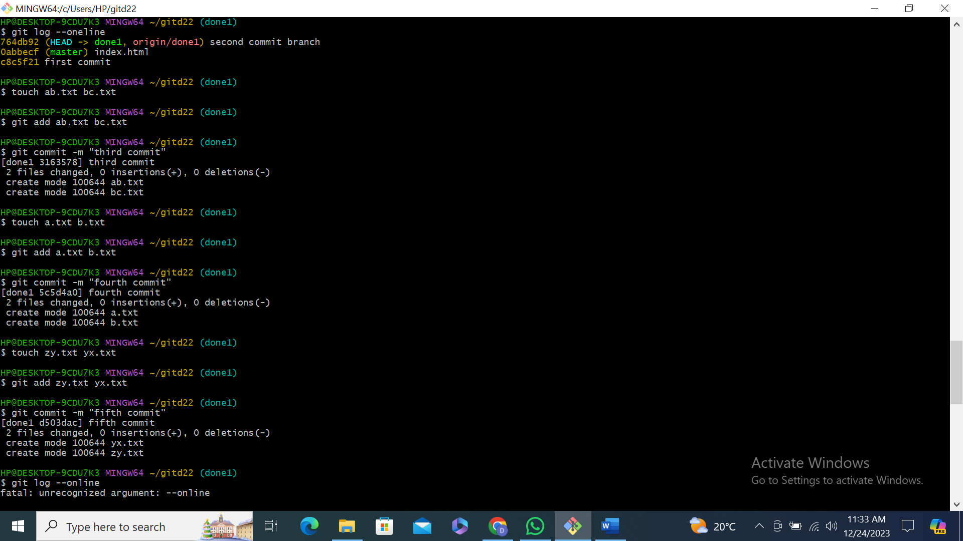

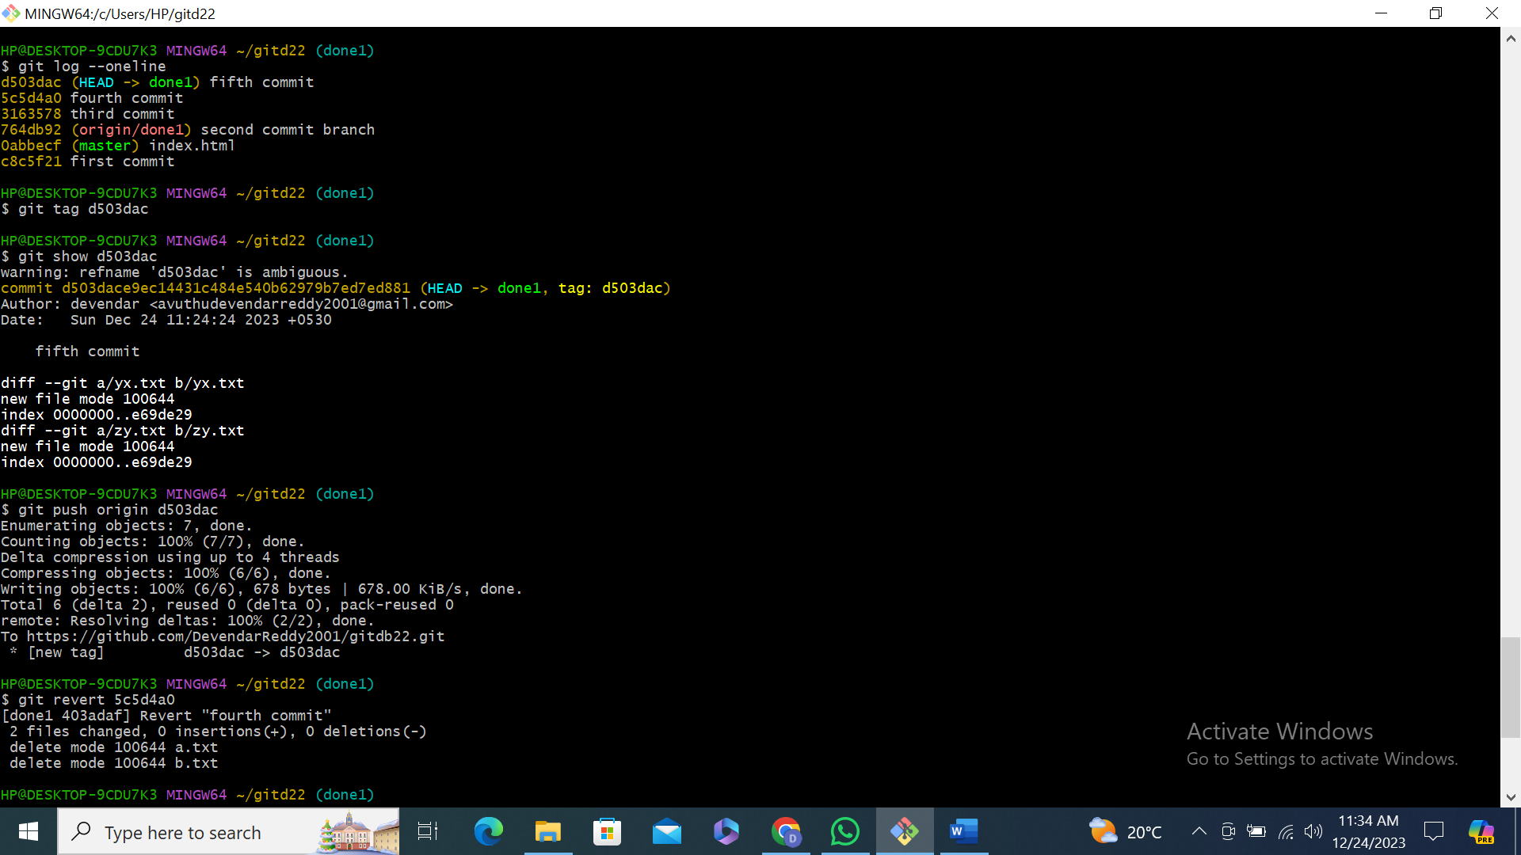

git push origin d503dac

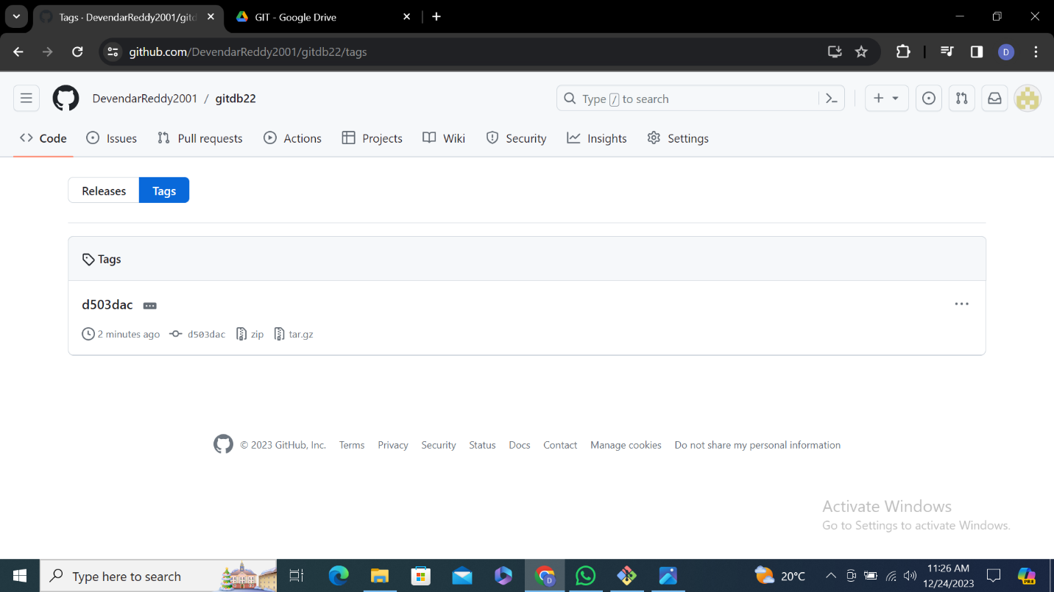

git revert 5c5d4a0

git log –oneline

git reset 3163578(soft)

